Darknet Security: A Categorization of Attacks to the Tor Network
ABSTRACT
In the darknet security topic, it is important to analyze the threats that characterize the network. This paper deeply investigates the literature of attacks against the Tor network, presenting the most relevant threats in this context. In order to provide an important tool for the research community, we propose an exhaustive taxonomy based on the target of the attack. Such taxonomy represents a characterization scheme to identify cyber-attacks related to darknet environments and better understand their functioning. The proposed work should therefore be considered an important step forward in the darknet security field.
EXISTING SYSTEM
In the darknet security topic, it is important to analyze the threats that characterize the network. This paper deeply investigates the literature of attacks against the Tor network, presenting the most relevant threats in this context. In order to provide an important tool for the research community
Disadvantages of Existing System
- Not secure

PROPOSED SYSTEM
In this paper, we have investigated the darknet security topic, related to attacks that are related to a darknet environments. By focusing on the Tor onion network [5], we have deeply investigated the literature of cyber-attacks exploiting such system. In order to provide a more easy to understand overview of the threats against darknet environments, we have proposed an easy-to-understand categorization of attacks against darknet environments, by also categorizing the investigated threats. The proposed categorization should be considered an important step in the darknet security context, since it provides an important tool to classify threats, hence, to better understand them and to propose efficient protection systems. we propose an exhaustive taxonomy based on the target of the attack. Such taxonomy represents a characterization scheme to identify cyber-attacks related to darknet environments and better understand their functioning. The proposed work should therefore be considered an important step forward in the darknet security field.
Advantages of Proposed System
- being a crucial element for users activities, governments, and critical infrastructure systems.
- Internet network has to be kept a safe place for its users and inter-communicating systems, ensuring secure communications and guaranteeing users rights.
SYSTEM REQUIREMENTS
System Architecture

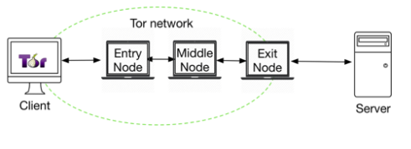
Fig.1 Tor Communication Sample

Hardware Requirements:

Processor - Pentium –IV
- Speed - 1.1 GHz
- Ram - 256 MB
- Hard Disk - 20 GB
- Key Board - Standard Windows Keyboard
- Mouse - Two or Three Button Mouse
- Monitor - SVGA
Software Requirements:
- Operating System - Windows XP
- Coding Language - Java

